- \Operation\Agitator\Agitator
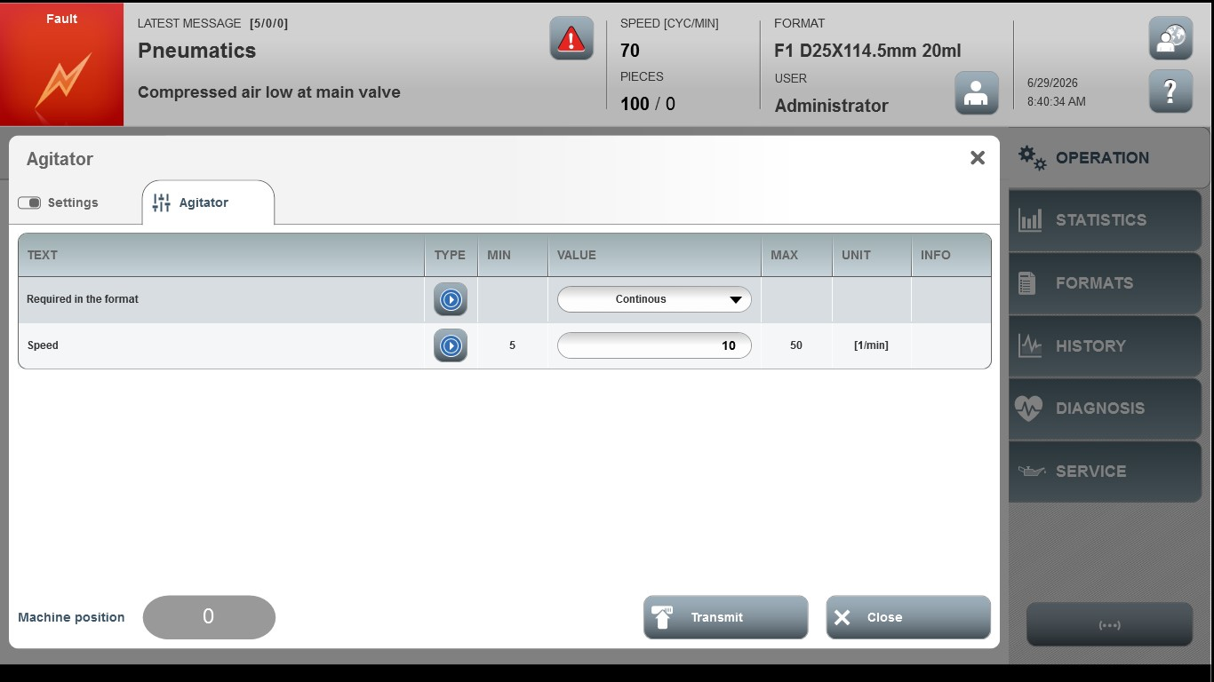
Acceptance criterion | Limits | Pass / Fail: Dev-No. | Date | Initials
Screen matches screenshot | N / A
Speed | 5 … 50

